Changes in Query

1)Changed inner joins on LKUP_diagnosisMulti and LKUP_diagnosis to include visits with no keys in these tables (i.e. visits with no selected diagnoses)

2)Join on Age was using wrong foreign key(should be agekey not ageorder).

3) Added visits marked as comfortable

4) Got rid of diagnosisLabel not like %No Diagnosis%. This line was needed in quickforms1, but not quickforms3.

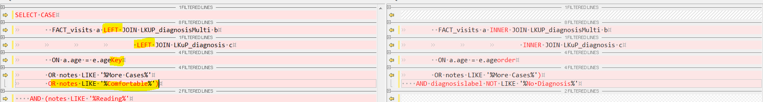

Self-Assessment Current Funtionality

The self-assessment report displays data based on an individual diagnosis. If a visit has 2 or more diagnosis and it is marked as “Reading, More Cases”, then ALL diagnoses will appear in the self-assessment report individually (one row for each diagnosis). See attached image:

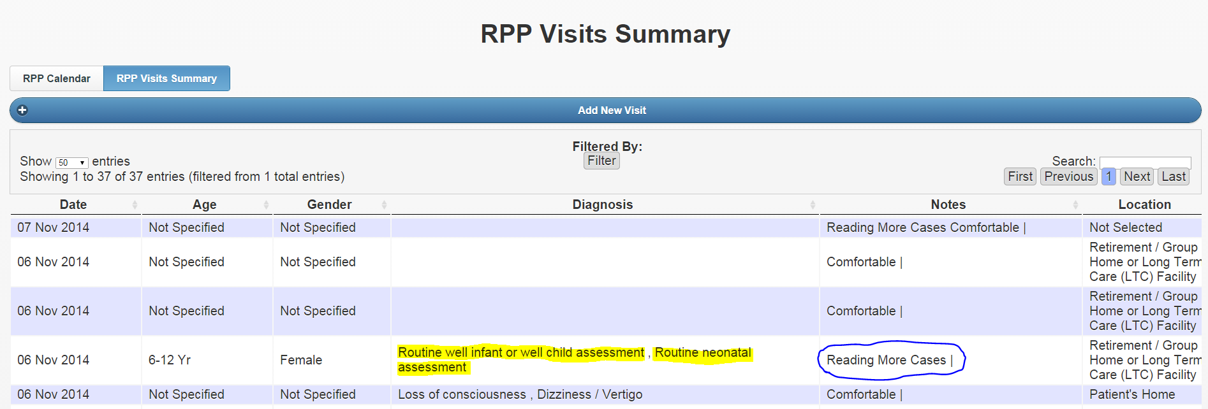

Same visit with 2 entries in the self-assessment report

